Christer Fuglesang Space Center in a nutshell
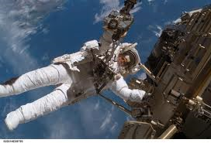
Christer Fuglesang Space Center will be a visible symbol for human exploration of the unknown beyond the known. The Center shall communicate the importance and value of free and interdisciplinary research and its´ practical applications, and that such work may be a life mission offering great personal satisfaction.
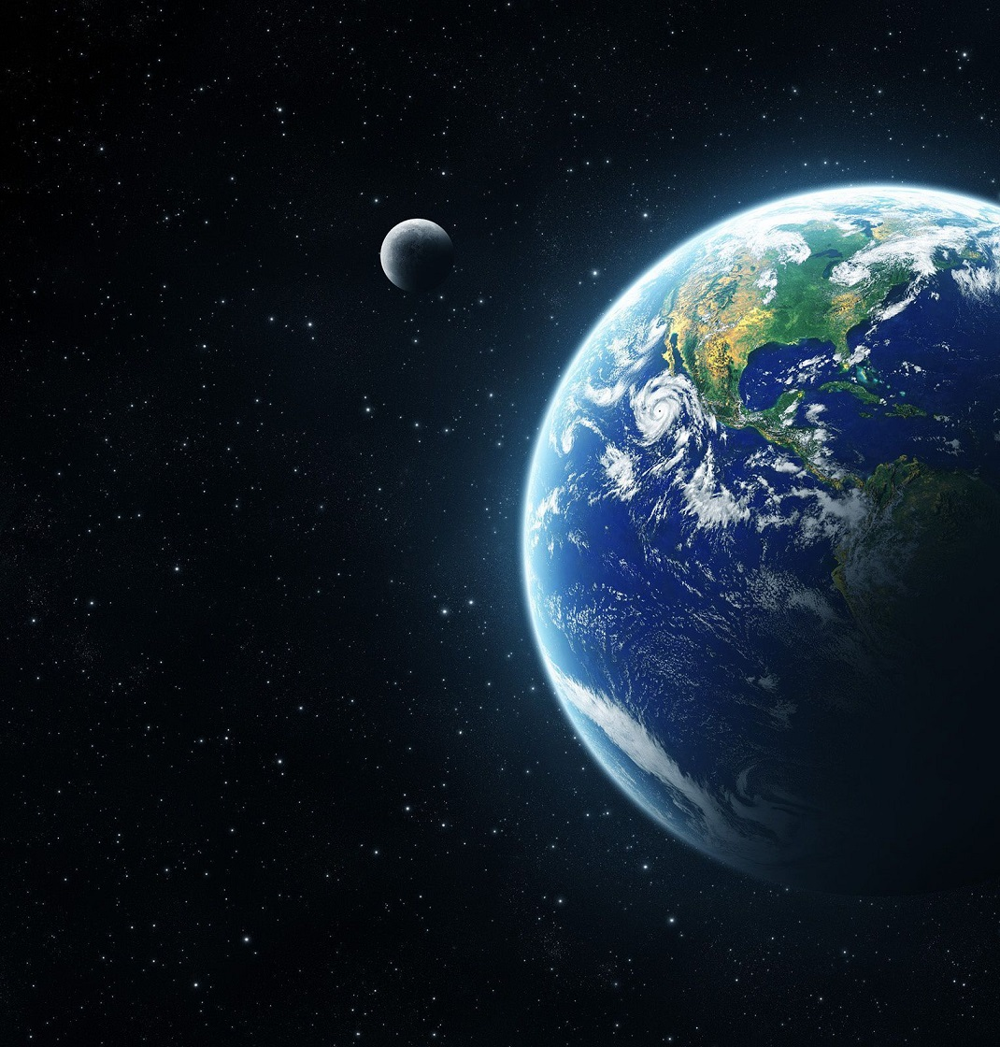
The Center shall also communicate a message of Sweden as a country with considerable experience in space technology, and of Stockholm as a world class university city, sustainable city and tourist destination.
The entire building will be constructed for sustainability, involving knowledge of how to create closed-loop living in space. Possible Swedish sister to NASA Sustainability Base in San Fransisco - sustainable and energy positive. Suggested location is “the Round House” of the new “Haga City” (Hagastaden). There will be two closely integrated parts: Inspiration and Learning and Living, Meeting and Working.

Inspiration and Learning (Ground floor and floors 1-3):
Entrance. A common area with entrances to the Space Center and “the Space Flight”, as well as shops, restaurant, coffee shop, temporary small space related exhibitions, lifts, amenities, etc.
Space Center. Experiences/exhibition. International orientation with visiting exhibitions and educational materials being continually renewed to reflect and present the latest research findings. Also learning through hands-on exercises at age divided stations, based on school curricula and high school/university courses in physics, chemistry, technology and biology. Offices, laboratories and temporary exhibition space for companies and scholars with a space agenda.
The Space School. Boarding school for visiting school classes from across Sweden. 2-3 days of intensive science courses. Experiments in physics/chemistry/biology, hard to conduct in ordinary schools.

Living, Meeting and Working (floors 4-11):
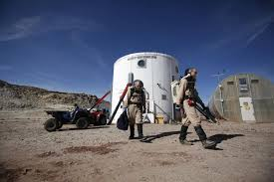
Hotel, serviced apartments and researcher´s apartments. Module based. Different themes, such as Mars, The Moon, Space Station, etc. Option to spend a few days in a simulated space colony, where virtual windows of high definition screens support the illusion.
Conference center. Visualisation room for round table discussions with up to 1 000 participants and many more via video link. Combined with Aula Medica at nearby Karolinska Institutet, a world class international conference center is created.
Roof top terrace. Rooftop bar and congress restaurant with a city-wide view. Rooftop garden with space theme. Opens to 10-20 inner light shaft passing through entire building. Sun mirrored in.
Transportation
Subway Station and other public transport services. VIP-entrance with entry/exit to ”Norra Länken”.

